ABSTRACT

Goods and Services Tax (GST) is an indirect tax (or consumption tax) imposed in India on the supply of goods and services. It is a comprehensive multistage, destination based tax. Comprehensive because it has subsumed almost all the indirect taxes except few. Multi-Staged as it is imposed at every step in the production process, but is meant to be refunded to all parties in the various stages of production other than the final consumer. And destination based tax, as it is collected from point of consumption and not point of origin like previous taxes.
Goods and services are divided into five tax slabs for collection of tax - 0%, 5%, 12%, 18% and 28%. However, Petroleum products, alcoholic drinks, electricity, are not taxed under GST and instead are taxed separately by the individual state governments, as per the previous tax regime.^{[citation needed]} There is a special rate of 0.25% on rough precious and semi-precious stones and 3% on gold.^{[1]} In addition a cess of 22% or other rates on top of 28% GST applies on few items like aerated drinks, luxury cars and tobacco products.^{[2]} Pre-GST, the statutory tax rate for most goods was about 26.5%, Post-GST, most goods are expected to be in the 18% tax range
The tax came into effect from July 1, 2017 through the implementation of One Hundred and First Amendment of the Constitution of India by the Indian government. The tax replaced existing multiple flowing taxes levied by the central and state governments.
The tax rates, rules and regulations are governed by the GST Council which consists of the finance ministers of centre and all the states.

ABSTRACT |  | i
CONTENTS |  | ii
CONTENTS |  | iii
CHAPTER 1: INTRODUCTION |  | 1
 |  | 1
- GST MEANING  - GST ID |  | 1
 |  | 2
CHAPTHER 2: ARCHITECTURE |  | 3
 |  | 3
 |  | 4
 |  | 4
 |  | 6
 |  | 7
CHAPTER 3:ANALYSIS AND DESIGN |  | 8
1.USER END
2.SERVER END
 |  | 8
 |  | 9
 |  | 10
CHAPTER 4: IMPLEMENTATION |  | 18
4.1 connecting to gst.gov.in |  | 18
4.2 Source code |  | 22
 |  | 38
 |  | 38
CHAPTER 6: SNAPSHOTS |  | 43
CONCLUSION |  | 50
REFERENCES |  | 51

iii
Loan Management System | 2018-2019
Chapter 1 | Introduction
1.1 Aims and Objectives

AIMS: HELP THE GST USER TO PAY GST BILLS THROUGH ONLINE WITH DOCUMENTATION AND SECURITY.

1.2 Problem Statement

TO FIND SOLUTION TO GST USER TO PAY GST BILLS THROUGH ONLINE WITH DOCUMENTATION AND SECURITY.

1.3 Hardware and Software Requirements

1.3.1 Software Requirements

1 Software Requirements :

· OS: Windows XP, 7 or above.
· Editor: Android studio.
· Toolkit: ADT: Android Developer Tools , JDK.

2 Hardware Requirements :

· Desktop/laptop.
· Android smart phone.
· RAM: 4GB/Above both for client and server.
· Processor: i3/Above.

Loan Management System | 2018-19
9

Department of CS&E,JIT,DVG P a g e | 2
Loan Management System | 2018-19

Chapter Results and Analysis

- User End: User can either capture or obtain an image from gallery. User sends the image to the server side for further process which involves Feature Extraction, Feature Matching. Final result is displayed on the user App.

- Server End: The image is uploaded from the client side. The Server Search the image in the database using Then server send Required response to the client side.

Department of CS&E,JIT,DVG P a g e | 3
Loan Management System | 2018-19

Loan Management System | 2018-19

e creating new records etc.

IV. Maintainability

Backups for database is available.

- Portability

The software is web based applicaton and is built in PHP and MySql, so it is platform independent and is independent of operating system.

Department of CS&E,JIT,DVG
Loan Management System | 2018-19

2.4 Architecture

Department of CS&E,JIT,DVG
Loan Management System | 2018-19

Department of CS&E,JIT,DVG
Loan Management System |  | 2018-19

Fig:3.1 ER Diagram of Hotel Management System

Loan Management System | 2018-19

3.2.2 Use Case Diagram

Admin Use Case diagram
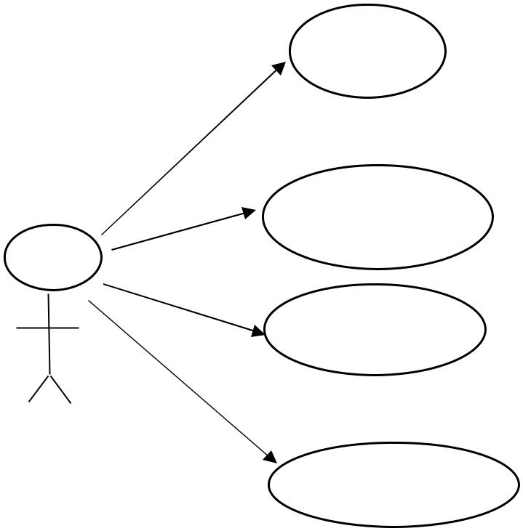

Log in

Add Hotel

Add Coustemers

Add

Fig:3.3 Admin Use Case Diagram

3.3 Technologies used

Android bucket

Loan Management System | 2018-19

3.3.1 PHP

Loan Management System | 2018-19

Loan Management System | 2018-19

Example:

3.3.3 HTML

Department of CS&E,JIT,DVG
Loan Management System | 2018-19

Department of CS&E,JIT,D
Loan Management System | 2018-19

Fig: 3.6 Parameters Description

?>

Loan Management System | 2018-19
Chapter 4 | Implementation

Department of CS&E,JIT,DVG
Loan Management System | 2018-19

4.2 Source Code

package cse.tax_sevak;

import android.content.Intent;
import android.support.v7.app.AppCompatActivity;
import android.os.Bundle;
import android.view.View;
import android.widget.Button;
import android.widget.EditText;
import android.widget.Toast;

public class calActivity extends AppCompatActivity {

@Override
protected void onCreate(Bundle savedInstanceState) {
super.onCreate(savedInstanceState);
setContentView(R.layout.activity_cal);

final EditText ed, etd1, etd2,etd3;

Button butt1 = (Button) findViewById(R.id.b1);
Button but2 = (Button) findViewById(R.id.b2);
Button but3 = (Button) findViewById(R.id.b3);
Button but4 = (Button) findViewById(R.id.b4);
Button but5 = (Button) findViewById(R.id.b5);
Button but6 = (Button) findViewById(R.id.b6);
Button but7 = (Button) findViewById(R.id.b7);
Button but8 = (Button) findViewById(R.id.b8);
Button but9 = (Button) findViewById(R.id.b9);
Button but10 = (Button) findViewById(R.id.b10);
Button but11 = (Button) findViewById(R.id.b11);
Button but12 = (Button) findViewById(R.id.b12);
Button but13 = (Button) findViewById(R.id.b13);
Button but14 = (Button) findViewById(R.id.b14);
Button but15 = (Button) findViewById(R.id.b15);
Button but16 = (Button) findViewById(R.id.b16);
Button but17 = (Button) findViewById(R.id.b17);
Button but19 = (Button) findViewById(R.id.b19);
Button but20 = (Button) findViewById(R.id.b20);

=
ed = (EditText) findViewById(R.id.ed1);
etd1 = (EditText) findViewById(R.id.ed2);
etd2 = (EditText) findViewById(R.id.ed3);
etd3 = (EditText) findViewById(R.id.ed4);

butt1.setOnClickListener(new View.OnClickListener() {
@Override
public void onClick(View v) {
ed.setText(ed.getText() + "1");
}
});
but2.setOnClickListener(new View.OnClickListener() {
@Override
public void onClick(View v) {
ed.setText(ed.getText() + "2");
}
});
but3.setOnClickListener(new View.OnClickListener() {
@Override
public void onClick(View v) {
ed.setText(ed.getText() + "3");
}
});
but4.setOnClickListener(new View.OnClickListener() {
@Override
public void onClick(View v) {
ed.setText(ed.getText() + "4");
}
});

but5.setOnClickListener(new View.OnClickListener() {
@Override
public void onClick(View v) {
ed.setText(ed.getText() + "5");
}
});

but6.setOnClickListener(new View.OnClickListener() {
@Override
public void onClick(View v) {
ed.setText(ed.getText() + "6");
}
});

but7.setOnClickListener(new View.OnClickListener() {
@Override
public void onClick(View v) {
ed.setText(ed.getText() + "7");
}
});

but8.setOnClickListener(new View.OnClickListener() {
@Override
public void onClick(View v) {
ed.setText(ed.getText() + "8");
}
});

but9.setOnClickListener(new View.OnClickListener() {
@Override
public void onClick(View v) {
ed.setText(ed.getText() + "9");

}
});

but10.setOnClickListener(new View.OnClickListener() {
@Override
public void onClick(View v) {
ed.setText(ed.getText() + "0");
}
});

but11.setOnClickListener(new View.OnClickListener() {
@Override
public void onClick(View v) {
ed.setText(" ");
etd1.setText(" ");
etd2.setText(" ");
etd3.setText(" ");
}
});

but12.setOnClickListener(new View.OnClickListener() {
@Override
public void onClick(View v) {
Float a,c,d;
a = Float.parseFloat(ed.getText().toString());
c = a * 0/100;
d = a+c+c;
etd1.setText("CGST = \t "+ Float.toString(c));
etd2.setText("SGST = \t "+ Float.toString(c));
etd3.setText("Total amount= "+ Float.toString(d));
}
});

but13.setOnClickListener(new View.OnClickListener() {
@Override
public void onClick(View v) {
Float a,c,d;
a = Float.parseFloat(ed.getText().toString());
c = a * 5/100;
d = a+c+c;
etd1.setText("CGST = \t "+ Float.toString(c));
etd2.setText("SGST = \t "+ Float.toString(c));
etd3.setText("Total amount= "+ Float.toString(d));
}
});

but14.setOnClickListener(new View.OnClickListener() {
@Override
public void onClick(View v) {
Float a,c,d;
a = Float.parseFloat(ed.getText().toString());
c = a * 12/100;
d = a+c+c;
etd1.setText("CGST = \t "+ Float.toString(c));
etd2.setText("SGST = \t "+ Float.toString(c));
etd3.setText("Total amount= "+ Float.toString(d));
}
});

but15.setOnClickListener(new View.OnClickListener() {
@Override
public void onClick(View v) {
Float a,c,d;
a = Float.parseFloat(ed.getText().toString());
c = a * 18/100;
d = a+c+c;
etd1.setText("CGST = \t "+ Float.toString(c));
etd2.setText("SGST = \t "+ Float.toString(c));
etd3.setText("Total amount= "+ Float.toString(d));
}
});

but16.setOnClickListener(new View.OnClickListener() {
@Override
public void onClick(View v) {
Float a,c,d;
a = Float.parseFloat(ed.getText().toString());
c = a * 28/100;
d = a+c+c;
etd1.setText("CGST = \t "+ Float.toString(c));
etd2.setText("SGST = \t "+ Float.toString(c));
etd3.setText("Total amount= "+ Float.toString(d));
}
});

but17.setOnClickListener(new View.OnClickListener() {
@Override
public void onClick(View v) {
Float a,c,d;
a = Float.parseFloat(ed.getText().toString());
c = a * 3/100;
d = a+c+c;
etd1.setText("CGST = \t "+ Float.toString(c));
etd2.setText("SGST = \t "+ Float.toString(c));
etd3.setText("Total amount= "+ Float.toString(d));
}
});

but19.setOnClickListener(new View.OnClickListener() {
@Override
public void onClick(View v) {
Float a,c,d;
a = Float.parseFloat(ed.getText().toString());
c = a * 25/1000;
d = a+c+c;
etd1.setText("CGST = \t "+ Float.toString(c));
etd2.setText("SGST = \t "+ Float.toString(c));
etd3.setText("Total amount= "+ Float.toString(d));
}
});
but20.setOnClickListener(new View.OnClickListener() {
@Override
public void onClick(View v) {
Float a,c,d;
a = Float.parseFloat(ed.getText().toString());
c = a * 10/100;
d = a+c+c;
etd1.setText("CGST = \t "+ Float.toString(c));
etd2.setText("SGST = \t "+ Float.toString(c));
etd3.setText("Total amount= "+ Float.toString(d));
}
});

}

}

package cse.tax_sevak;

import android.content.Intent;
import android.net.Uri;
import android.support.v7.app.AppCompatActivity;
import android.os.Bundle;
import android.view.View;
import android.widget.Button;

public class ewayBill extends AppCompatActivity {

@Override
protected void onCreate(Bundle savedInstanceState) {
super.onCreate(savedInstanceState);
setContentView(R.layout.activity_eway_bill);

Button but1=(Button)findViewById(R.id.el1);
Button but2=(Button)findViewById(R.id.eb2);

Button but3=(Button)findViewById(R.id.eb3);
Button but4=(Button)findViewById(R.id.eb4);

Button but5=(Button)findViewById(R.id.eb5);
Button but6=(Button)findViewById(R.id.eb6);

Button but7=(Button)findViewById(R.id.eb7);

but1.setOnClickListener(new View.OnClickListener(){
@Override
public void onClick(View v) {
Uri uri = Uri.parse("https://ewaybillgst.gov.in/login.aspx");
Intent int1 = new Intent(Intent.ACTION_VIEW, uri);
startActivity(int1);
}
});

but2.setOnClickListener(new View.OnClickListener(){
@Override
public void onClick(View v) {
Uri uri = Uri.parse("https://ewaybillgst.gov.in/Account/EWBUserRegistration.aspx");
Intent int1 = new Intent(Intent.ACTION_VIEW, uri);
startActivity(int1);
}
});

but3.setOnClickListener(new View.OnClickListener(){
@Override
public void onClick(View v) {
Uri uri = Uri.parse("https://ewaybillgst.gov.in/Others/TaxPayerSearch.aspx");
Intent int1 = new Intent(Intent.ACTION_VIEW, uri);
startActivity(int1);
}
});

but4.setOnClickListener(new View.OnClickListener(){
@Override
public void onClick(View v) {
Uri uri = Uri.parse("https://ewaybillgst.gov.in/Others/TransportersSearch.aspx");
Intent int1 = new Intent(Intent.ACTION_VIEW, uri);
startActivity(int1);
}
});

but5.setOnClickListener(new View.OnClickListener(){
@Override
public void onClick(View v) {
Uri uri = Uri.parse("https://ewaybillgst.gov.in/Others/ProductSearch.aspx");
Intent int1 = new Intent(Intent.ACTION_VIEW, uri);
startActivity(int1);
}
});

but6.setOnClickListener(new View.OnClickListener(){
@Override
public void onClick(View v) {
Uri uri = Uri.parse("https://ewaybillgst.gov.in/Others/EBPrintnew.aspx");
Intent int1 = new Intent(Intent.ACTION_VIEW, uri);
startActivity(int1);
}
});

but7.setOnClickListener(new View.OnClickListener(){
@Override
public void onClick(View v) {
Uri uri = Uri.parse("https://ewaybillgst.gov.in/Others/ewb.html");
Intent int1 = new Intent(Intent.ACTION_VIEW, uri);
startActivity(int1);
}
});
}
}

package cse.tax_sevak;

import android.content.Intent;
import android.support.v7.app.AppCompatActivity;
import android.os.Bundle;
import android.view.View;
import android.widget.Button;

public class gstRates extends AppCompatActivity {

@Override
protected void onCreate(Bundle savedInstanceState) {
super.onCreate(savedInstanceState);
setContentView(R.layout.activity_gst_rates);

Button butt1=(Button)findViewById(R.id.g1);
Button butt2=(Button)findViewById(R.id.g2);
Button butt3=(Button)findViewById(R.id.g3);

butt1.setOnClickListener(new View.OnClickListener(){
@Override
public void onClick(View v) {
Intent int1=new Intent(gstRates.this,goodsRate.class);
startActivity(int1);
}
});

butt2.setOnClickListener(new View.OnClickListener(){
@Override
public void onClick(View v) {
Intent int2=new Intent(gstRates.this,goodsRate.class);
startActivity(int2);
}
});

butt3.setOnClickListener(new View.OnClickListener(){
@Override
public void onClick(View v) {
Intent int3=new Intent(gstRates.this,search.class);
startActivity(int3);
}
});

}
==}
Loan Management System | 2018-19

Chapter 6 | Snap Shots

6.1 Home Page

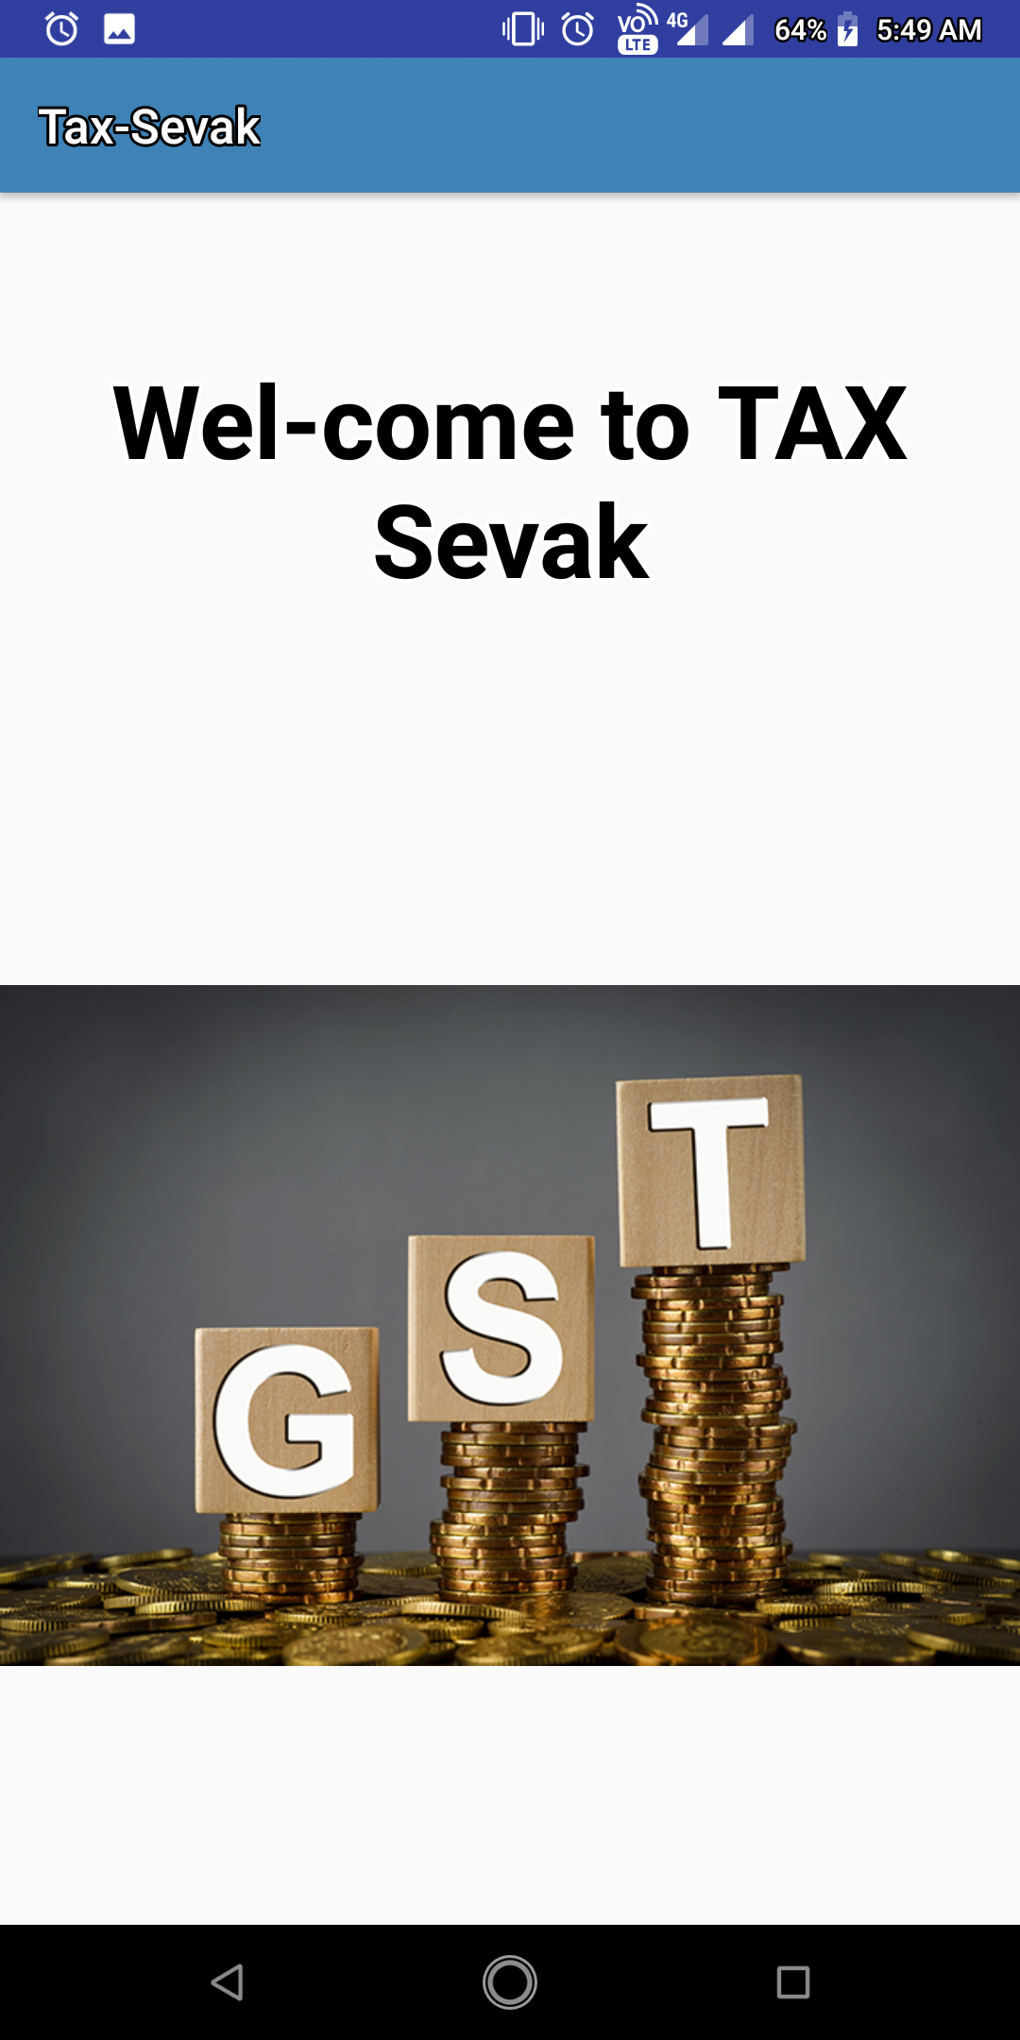

Fig:6.1 Home Page

Loan Management System | 2018-19

Conclusion

Hotel management simplifies the management process in hotel. Fast processing and immediate servises with high security. Navigation through the site is easy.
In this project we study the hotel database system. It is developed using the WAMP server. For elaborating the system we have used simple E-R diagram.

Loan Management System | 2018-19

- Websites

